**Introduction to Apache TomEE**

**Apache TomEE** (pronounced "Tommy") is the Enterprise Edition of Apache Tomcat (Tomcat + Java/Jakarta EE = TomEE) that combines several Java enterprise projects including Apache OpenEJB, Apache OpenWebBeans, Apache OpenJPA, Apache MyFaces and others. In October 2011, the project obtained certification by Oracle Corporation as a compatible implementation of the Java EE 6 Web Profile.

**Components**

TomEE includes the following open-source components:

|  |  |
| --- | --- |
| **Component** | **Description** |
| Apache Tomcat | HTTP server and Servlet container supporting Java Servlet and JavaServer Pages (JSP). |
| Apache OpenEJB | Open-source Enterprise JavaBeans (EJB) container system. |
| Apache OpenWebBeans | Open-source Java Contexts and Dependency Injection (CDI) implementation. |
| Apache OpenJPA | Open-source Java Persistence API (JPA) 2.1 implementation. |
| Apache Geronimo Transaction | Open-source Java Transaction API (JTA) 1.2 implementation. |
| Apache MyFaces | Open-source Java Server Faces (JSF) implementation. |
| Apache ActiveMQ | Open-source Java Message Service (JMS) implementation. |
| Apache CXF | Web Services frameworks with a variety of protocols - such as SOAP, XML/HTTP, RESTful [HTTP](https://en.wikipedia.org/wiki/HTTP). |
| Apache Derby | Full-fledged relational database management system (RDBMS) with native Java Database Connectivity (JDBC) support. |

**TomEE JAX-RS**, a second distribution, adds support for Java API for RESTful Web Services (JAX-RS).

The full **TomEE Plus** distribution adds additional support for:

* Java API for XML Web Services (JAX-WS)
* Java EE Connector Architecture
* Java Messaging Service (JMS)

#### **TomEE Flavors**

Apache TomEE comes with four different flavors, Web Profile, MicroProfile, Plus and Plume. Apache TomEE Web Profile delivers Servlets, JSP, JSF, JTA, JPA, CDI, Bean Validation and EJB Lite. Apache TomEE MicroProfile adds support for MicroProfile. Apache TomEE Plus and Plume add support for JMS, JAX-WS and more.

## Main differences between versions

Apache TomEE is an open source software implementation of the Jakarta EE (formally Java EE) technologies.  
Different versions of Apache TomEE are available for different versions of the specifications.  
The mapping between the specifications and the respective Apache TomEE versions is:

| **TomEE version** | **Based on Tomcat** | **Java SE version** | **Micro Profile version** | **Jakarta EE version** |
| --- | --- | --- | --- | --- |
| 9.x | 10.0.x | 11 | 5.0 | 9.1 |
| 8.x | 9.0.x | 8 | 2.0 | 8.0 |
| 7.1.x | 8.5.x | 7 or 8 | 1.4 | 7.0 |
| 7.0.x | 8.5.x | 7 or 8 |  | 7.0 |

Jakarta EE 9.x introduces breaking changes (relocation from javax.* to jakarta.* namespace). When in doubt choose Jakarta EE 8 and TomEE 8.x

Tomcat supports only a subset of Jakarta EE while TomEE is fully compliant.

## Synthesis of differences between flavors

Apache TomEE has four distributions, each supporting a slightly different set of technologies and aimed to give you a choice in what you want included out-of-the-box. When in doubt, choose Apache TomEE Plume.

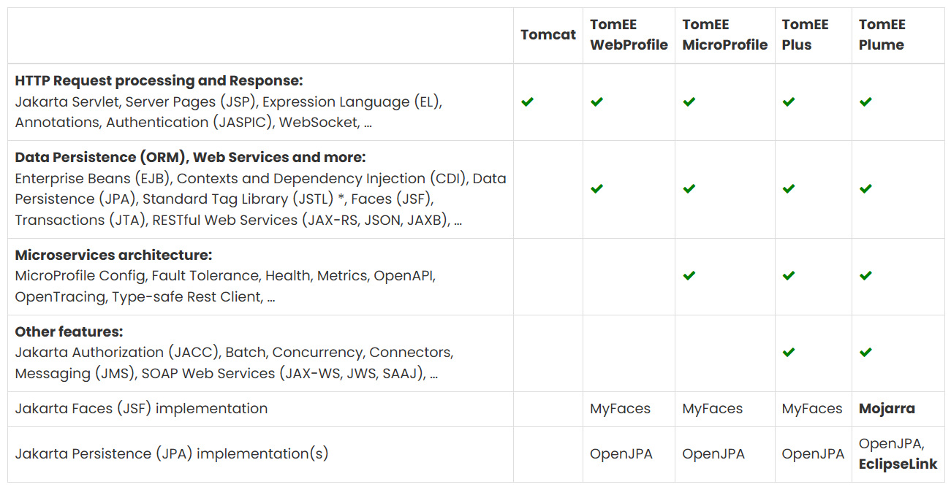

* Please note that Tomcat does not ship with the jars for Standard Tag Library (JSTL) nor the security.enterprise.* packages.

## Detailed list of Jakarta EE and MicroProfile specifications

## 

## 

## 

## 

* Please note that Tomcat does not ship with the jars for Standard Tag Library (JSTL) nor the security.enterprise.* packages.

## Implementations of Jakarta EE and MicroProfile features in TomEE

| **Specifications** | **Implementations included by TomEE** |
| --- | --- |
| Jakarta Servlet, Server Pages (JSP), Expression Language (EL), Jakarta Annotations, Authentication (JASPIC), WebSocket, …​ | Apache Tomcat |
| Jakarta Standard Tag Library (JSTL) | Apache Standard Taglib Implementation |
| Jakarta Faces (JSF) | Apache MyFaces **(shipped in all TomEE flavors except Plume)** Eclipse Mojarra **(shipped in TomEE Plume)** |
| Jakarta Contexts and Dependency Injection (CDI) | Apache OpenWebBeans |
| Jakarta Enterprise Beans (EJB) | Apache OpenEJB |
| Jakarta Transactions (JTA) | Apache Geronimo Transaction Manager |
| Jakarta Persistence (JPA) | Apache OpenJPA (shipped in all TomEE flavors) EclipseLink **(shipped in TomEE Plume)** |
| Jakarta Bean Validation | Apache BVal |
| Web Services | Apache CXF |
| Jakarta JSON Binding (JSON-B), Jakarta JSON Processing (JSON-P) | Apache Johnzon |
| Jakarta XML Binding (JAXB) | Eclipse Implementation of JAXB |
| Jakarta Mail (JavaMail) | Apache Geronimo JavaMail |
| MicroProfile | Apache Geronimo MicroProfile **(ok only with TomEE 7.1.x and 8.x)** SmallRye MicroProfile **(ok with TomEE 9.x and later)** |
| Jakarta Batch (JBatch) | Apache BatchEE |
| Jakarta Messaging (JMS) | Apache ActiveMQ |

In bold : Implementations that differ between flavors or between versions

## Compatibility with other implementations

| **Specifications** | **Implementations alternatives** |
| --- | --- |
| Jakarta Persistence (JPA) | Hibernate ORM |
| Jakarta MVC | Eclipse Krazo  **(ok with TomEE 8.x and later)** |
| Other containers (CDI, EJB, JTA, etc.) and frameworks | Spring |

* Please note that TomEE does not ship with the jars for Hibernate, Jersey, Krazo, Spring.